Management Information Systems, 16E

Laudon & Laudon

Lecture Notes by Barbara J. Ellestad

Chapter 9 Achieving Operational Excellence and Customer Intimacy: Enterprise Applications

Over the last decade businesses have come to realize how important it is to totally integrate business processes across the enterprise. We’ve spoken about “islands of information” many times. In today’s fast-paced world, managing information assets is more important than ever before. In this chapter we’ll look at how important it is for information to be available in every nook and cranny of an enterprise.

9.1 How do enterprise systems help businesses achieve operational excellence?

We’ve looked at enterprise resource planning systems in previous chapters and also discovered the importance of efficiently and effectively maintaining data that businesses can develop into useful information. As we’ve seen, it can be disastrous for an organization to have more than one set of data for customers, employees, and suppliers. The best idea is to have one database that supplies information where and when necessary across functional lines. Everyone from employees to managers, from customers to suppliers, would have the necessary tools to extract the data that they need and present it in the format that fits them best. That’s where enterprise systems enter the picture.

What Are Enterprise Systems?

Enterprise systems aim to correct the problem of firms not having integrated information. Also known as enterprise resource planning (ERP) systems, their main goal is to bridge the communication gap among all departments and all information users within a company. If production enters information about its processes, the data are available to accounting, sales, and human resources. If sales and marketing is planning a new advertising campaign, anyone anywhere within the organization will have access to that information. Enterprise systems truly allow a company to use information as a vital resource and enhance the bottom line.

Data integration throughout the firm is the key. Consolidated data from divisions and departments throughout the business, including key business processes, are immediately available to any authorized user. The greatest enticement of enterprise systems is the chance to cut costs firm-wide and enhance the ability to pass information throughout the organization.

Enterprise Software

Many businesses assume that their operations are totally integrated across functional lines. After all, manufacturing responds to an order from sales and produces a product for which accounting and finance sends an invoice. A production manager sends an e-mail to the human resources department requesting five new employees. When the marketing department decides on a new advertising campaign, a copy of the brochure is included in all employees’ pay envelopes at the end of the month. Once a week all department managers meet with the executive staff and review statistics from last month’s business.

What’s the problem? Many times, departments fail to fully communicate with all the other departments about every process that is taking place in a company. They don’t do it on purpose but forget how important total communication about every process and every piece of data is. Sales sends an order to manufacturing with a shipment date that can’t possibly be met. Accounting and finance pays a bill for supplies that production never ordered. Human resources holds a training class that interferes with a rush production job.

What’s the solution? Enterprise software allows every functional area to share every process and every piece of data. A business can select specific processes in specific areas but eventually everything the company does will be shared across all lines. The software uses predefined processes and requires the company to adapt itself to the software. While many companies may balk at having to change, the software is designed around the best practices for that particular function. The company can benefit from using the most successful solutions in a particular industry to help achieve its objectives. The software helps the organization automate many of the steps taken from industry-wide best practices instead of having to do everything manually. And best of all, the software will help employees remember all of the necessary steps in a process and provide the data to all who need it.

Table 9.1 is a list of the most common, most popular business processes that are automatically included in a typical enterprise system.

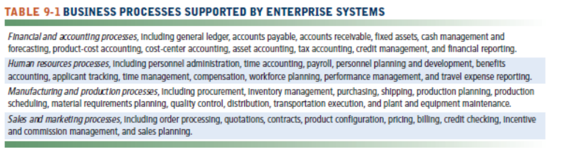

Although enterprise software can be somewhat modified, it is very expensive and very difficult to do so. Because the software is so complex, changing just one of the processes may disrupt some of the other interdependent modules. However, manufacturers of the enterprise software programs are modifying the software to envelop Internet services and make the data available to external sources such as suppliers, governmental agencies, and customers.

Business Value of Enterprise Systems

Done correctly, enterprise systems can offer big rewards. Conversely, done incorrectly can cause a firm huge headaches, loss of business, employee turmoil, and wasted dollars.

The benefits to the enterprise will be tremendous:

- Management: Improved management decision making, with a comprehensive view of performance across all functional areas.
- More efficient operations and customer-driven business processes: All functional areas can focus more on the customer and respond to product demand more efficiently.
- A more uniform organization: A more disciplined approach to business throughout the entire firm, regardless of physical location and/or organizational structure.

Interactive Session: Management: Soma Bay prospers with ERP in the Cloud (see page 345 of the text) shows the importance of having timely access to concise information and not just data. Management needed standardized business processes across functional areas and timely reports that explain the profitability of each business unit using a standard chart of accounts.

Bottom Line: Enterprise systems force a company to fully integrate all business processes. These systems usually require massive changes in the structure and organization of a business and are difficult to implement. However, the changes can make a tremendous improvement in a firm by using the best practices of the industry and requiring all functional areas to focus more on the customer.

9.2 How do supply chain management systems coordinate planning, production, and logistics with suppliers?

Oh, for the days when the old saying “the customer is king” was just a catch phrase. Now, it’s an absolute reality and companies that don’t live up to the phrase will get creamed in the marketplace. There are no more separate entities or distinct lines in the sand when it comes to integrating supply chains. It’s more like shifting sand.

The Supply Chain

A supply chain is similar to a spider’s web. It includes all of the internal functions of an organization, along with suppliers, distributors, retailers, and customers. They are all intertwined and rely on information from one another to effectively meet the business’s objectives.

Exactly what are all the activities involved in getting a product from conception to delivery? There are probably many more than you can easily think of. And there are many more people involved than you might imagine. It may be helpful to break the supply chain into three distinct groups:

- Upstream: Suppliers that deal directly with a manufacturer and their suppliers.
- Downstream: Distributors and those that deliver products to customers.
- Internal: The employees that transform materials, components, and services into the actual products.

Think of a mountain stream that starts very small, flows downhill, gathers more water as it combines with other streams, feeds into a river that continues to flow and eventually meets up with other rivers, and on into the ocean. The mountain stream is analogous to suppliers, the river represents manufacturers, and the ocean can be compared to customers.

Information Systems and Supply Chain Management

As with other functional areas, information is the glue that holds the supply chain together. Lack of or faulty information can wreak havoc on the entire chain from getting supplies into the manufacturing process and getting the final product to the customer.

In a perfect world, just-in-time strategies for ordering and delivering supplies would be an ordinary process. Unfortunately, we don’t live in a perfect world. Natural disasters, dock worker strikes, and terrorist activities such as September 11, 2001, can disrupt even the most carefully planned supply chains in an instant. Businesses have to plan as best they can around these kinds of events, but they can’t foresee every problem.

The bull-whip effect on the supply chain is more natural than you might think and happens in virtually every industry.

“The expression “Bullwhip Effect” was termed by executives of P&G, the company that manufactures the Pamper brand of diapers. These executives observed that while the consumer demand for Pamper’s Diapers was fairly constant over time, the orders for diapers placed by retailers to their wholesalers or distributors were quite variable i.e., exhibited significant fluctuations over time. In addition, even larger variations in order quantities were observed in the orders that P&G received from its wholesalers. This increase in the variability of the orders seen by each stage in a supply chain was called the bullwhip effect. This situation of misalignment in supply chain can be termed as ‘Asymmetric Information’ where different parties having different states of private information about demand conditions, products, and the chain operations.

The problem of this asymmetry arises because participating firms generally lack the knowledge required about each other’s plans and intentions to adequately harmonize their services and activities. Supply chain members often do not wish to share their private information completely and faithfully with all others due to the profitability of that actual or perceived information. Thereby the whole supply chain suffers from sub-optimal and opportunistic behavior. These decisions occur when the members don’t have sufficient visibility to resolve various trade-offs in decision making because the lack of information causes decisions to be made in a narrow scope that cannot ensure that products flow properly to end customers.

Moreover, with limited information sharing, members don’t have consistent perceptions of market needs and visibility over performance at the other levels of the supply chain. As a consequence, decisions are made based on either the best estimation of the available data or an educated guess. Such decisions can be biased and prevent the individual member from attaining the optimal solution of the supply chain. For example, the manufacturer often uses incoming orders with larger variance and not sales data from the retailer as a signal about the future product demand. Asymmetric information also produces problems of vulnerability of opportunistic behavior. Specifically, adverse selection and moral hazard manifest themselves in the relationship among the supply chain members. The negative selection of adverse selection, for example, is that the member firms cannot optimize supply chain performance because they don’t possess the required capability to meet the predetermined customer service level.” (Bullwhip Effect in Supply Chain, www.mbaknol.com, copied March 22, 2019)

In the example of the bull-whip effect explained above, if the diaper makers had been able to pass timely and accurate information to their suppliers, perhaps the sudden swing in supplying the product could have been avoided. Many companies don’t want to give up too much of their information because they fear that outsiders will compromise the information. Unfortunately, this way of old-style thinking costs too much money in terms of lost opportunities, overstocked and underused parts, and overpriced products.

Supply Chain Management Software

Supply chain planning systems can provide information up and down the chain and help everyone involved do a better forecasting job. In the example above, the information could pass more easily between the PC retailers and the parts suppliers. While the retailers were still remiss in accurately forecasting PC sales for the first quarter, the parts suppliers could have altered their manufacturing schedules quicker and avoided the huge inventory build-up.

Supply chain planning systems enable firms to:

- Generate demand forecasts.
- Develop sourcing and manufacturing plans.
- Share information about changes easier and faster so work can be better coordinated.
- Develop better demand planning that matches production closer with customer demands.
- Manage the flow of products through distribution centers and warehouses by using supply chain execution systems.
- Coordinate activities with supply chain partners.
- Handle complex interdependencies among various supply chain processes.
- Allow users to balance the costs of transportation, delivery, and handling.

Global Supply Chains and the Internet

The islands of information that we’ve frequently mentioned don’t exist just inside the corporation but also exist all up and down the supply chain. Adapting the supply chain software to the Internet and opening up information to suppliers, logistical experts, and distributors can greatly help a company reduce costs and ensure products are delivered when needed to the right location. It won’t help a company’s bottom line to have 1000 parkas delivered to southern Arizona in February when upstate New York is suffering through a difficult winter.

The same type of internal collaboration that organizations can generate through intranets can be extended to supply chain partners through extranets. Suppliers can log on to a company’s extranet site and review next week’s production schedule. The supplier can ensure enough production supplies are delivered to a manufacturer without over- or under-extending itself. Changes to the production schedule can be communicated easier to suppliers through Internet-enabled applications. Long-term forecasts can be posted to an extranet and schedules adjusted. No expensive proprietary systems are necessary because all information is transmitted through ordinary web-based applications. Internal and external users can use online applications to view delivery schedules or determine the optimal logistics for moving products.

Global Supply Chain Issues

Some of the issues businesses will face if they choose to use global supply chains are:

- Greater geographic distances and time differences
- Additional costs for transportation, inventory, and local taxes and fees
- Varying performance standards
- Foreign government regulations
- Cultural differences

Although the Internet helps suppliers, manufacturers, and partners communicate easier through e-mail, faxes, or phone calls, those communication methods open the door to errors or mistakes. Using web-based supply chain management systems gives all the players a way to make data and information more easily available through browsers and portals.

Using the Internet helps mitigate some of these issues, but it’s not a panacea for all of them. Companies must still deal with foreign governments and cultural differences for which there are no easy answers or Internet applications.

Demand-Driven Supply Chains: From Push to Pull Manufacturing and Efficient Customer Response

Traditionally, customers purchase whatever products are available. Although colors, sizes, and prices may vary somewhat, generally a manufacturer decides what to produce by forecasting what the potential demand might be through a push-based model. That is quickly changing to a pull-based model in which the customer tells the manufacturer ahead of time what he/she wants to buy. One of the best examples of this pull-based model is Dell Computer’s build-to-order business model. Dell doesn’t build a computer until it receives a customer order. Then it builds the computer to the customer’s specifications. Granted, the customer must choose from a pre-determined list of options, but Dell doesn’t have a huge stock of unsold inventory that no one wants based on faulty demand forecasting.

Figure 9.4 below shows the differences between the push-based and pull-based supply chain models.

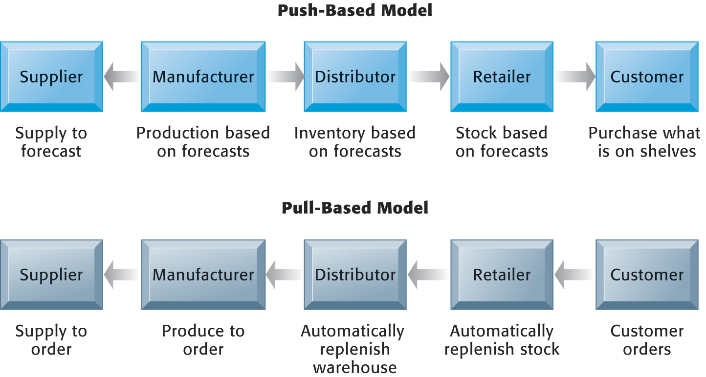

Figure 9.4: Push- vs. Pull-Based Supply Chain Models

Automobile manufacturers are also adopting pull-based modeling for their customers. A customer in Des Moines can log onto a web site and select the color, engine, options, and tires for her new car. The order is sent to the factory in Detroit and the manufacturer’s suppliers simultaneously. Although the customer must wait for delivery, at least she will get exactly the car she wanted. Figure 9.5 diagrams an Internet-driven supply chain.

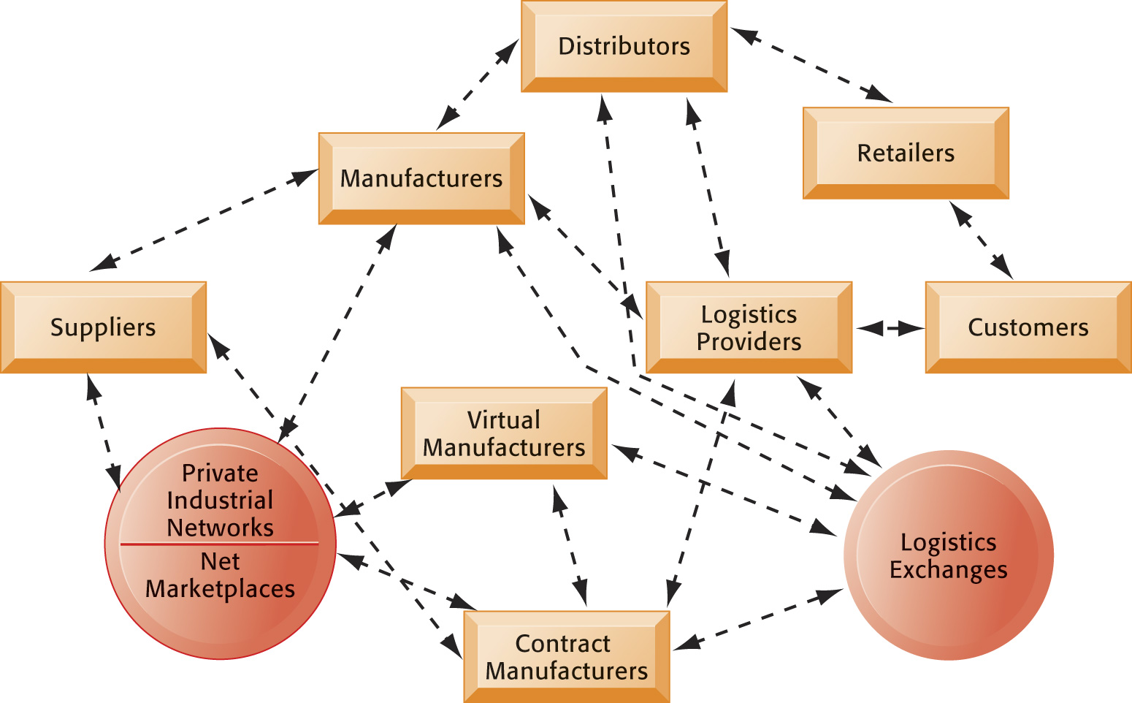

Figure 9.5: The Emerging Internet-Driven Supply Chain

Business Value of Supply Chain Management Systems

The benefits of implementing an integrated, networked supply chain management system include:

- Match supply to demand
- Reduce inventory levels
- Improve delivery service
- Speed product time to market
- Use assets more effectively

In turn a company can:

- Improve customer service and responsiveness
- Reduce costs
- Increase sales
- Utilize cash better

These last four benefits of implementing a supply chain management system point directly to improving the bottom line for the company. By making the supply chain more efficient a company can save millions of dollars, improve its relationships with its customers, and sell more products.

Bottom Line: Supply chain management systems integrate all of the processes by supplying information to all entities involved in the chain. More precise, current information allows organizations to improve demand forecasting and better measure the performance effectiveness of a supply chain. Better information also allows a firm to move from push-based to pull-based modeling.

9.3 How do customer relationship management systems help firms achieve customer intimacy?

“CRM involves merging the marketing efforts together with all business process so as to identify and manage important consumer relationships. It is basically about understanding the preferences and purchasing habits of customers to ensure that you are well placed in the market.
CRM benefits a business by making it simpler for the management to track every phase or step of an advertising campaign. It provides the essential tools that are needed for accurate campaign measurement and meaningful analysis. With CRM, you are able to profile clients based on a specific criterion, which is an important tool for any successful marketing strategy.
Most CRM applications offer a single viewpoint of the client across all channels and touch points. They also deliver comprehensive reports about current customer behaviors, sales activity and marketing results. All these elements are crucial for making smart decisions within the business and also for long term planning.
Nowadays, customers expect to receive a customized and streamlined experience at all time. An effective CRM system enables business to identify their customers quickly, address their main needs and also recommend extra services or products that may be of help to them. It gives staff the capability of recognizing who they are dealing with, which makes them more productive and more efficient. Clients, in turn, get to enjoy superior customer service along with lesser hassles.
When you have a proper CRM structure, you can easily gain instant access to the important customer information. Furthermore, good CRM applications also enhance internal efficiencies through automating the workflow processes, lowering process period and decreasing human error. CRM basically provides consistency throughout an entire organization .” (Benefits of CRM, benefitof.net/benefits-of-crm-2, Daniel, Harri, copied March 22, 2019)

Although many companies strive to be “customer-centric” very few have been able to completely focus every functional area of the organization on the customer. Largely due to new avenues of information customers have through the Internet, organizations must fight harder to keep the customers they worked so hard to get in the first place.

What Is Customer Relationship Management?

The goals of customer relationship management systems are to optimize customer satisfaction and customer retention, which in turn will maximize revenue and profitability.

Many companies are overloaded with data about customers. Unfortunately, too many companies don’t have any useful information that can help them increase customer satisfaction and retention, or thereby increase revenues and profitability. The ability to turn raw data into useful information is where CRM systems shine. CRM systems gather customer information from all corners of a business, consolidate the information, and then provide it to all of the organization’s customer touch points. By offering a consolidated viewpoint of the customer to these touch points, a company can cater to the customer who offers the most profitability.

Financial institutions are a prime example of how effective CRM systems can be at helping to identify the customers who offer the most “bang for the buck.” Most of the larger banks offer more than just checking and savings accounts. They provide investment services, insurance policies, and loans. It’s much cheaper for Wells Fargo bank for instance, to provide its current customers with all of these financial products, rather than trying to attract new customers for each of the separate product lines. Information gleaned from a CRM system provides Wells Fargo with information about which customers are more likely to purchase these products and its sales force targets that market better.

Customer Relationship Management Software

CRM application software ranges in size and complexity making it possible for an organization to select the type of software it needs the most. Modules focusing on partner relationship management or employee relationship management can be integrated into the customer relationship management software at a later date.

Partner relationship management systems reflect internal customer relationship management systems but extend past the immediate borders of a firm to its selling partners. For instance, Levi’s doesn’t sell directly to its customers but rather through other retail outlets. How Levi’s partners cater to the customer directly affects its profitability. Therefore, Levi’s is very interested in sharing information about its customers with its partners to increase sales of its products. Using partner relationship management systems not only helps Levi’s but also its retailers.

Employee relationship management modules associated with CRM focus more on how employees perform and interact with customers.

These modules help a company manage:
- Employee objectives
- Employee performance
- Performance-based compensation
- Employee training

Some of the more common capabilities of CRM software are:
- Sales force automation: Allows the sales force to focus on the most profitable customer. It also reduces the cost per sale for acquiring new customers and retaining old ones. Improves sales forecasting, territory management, and team selling.
- Customer service: Gathers information from a variety of sources and makes it available across organizational functions so that data is input only once. Includes web-based self-service capabilities.
- Marketing: Allows companies to engage in cross-selling, up-selling, and bundling through better analysis of customer data.

Figure 9.8 shows how customer data feeds into these three functions.

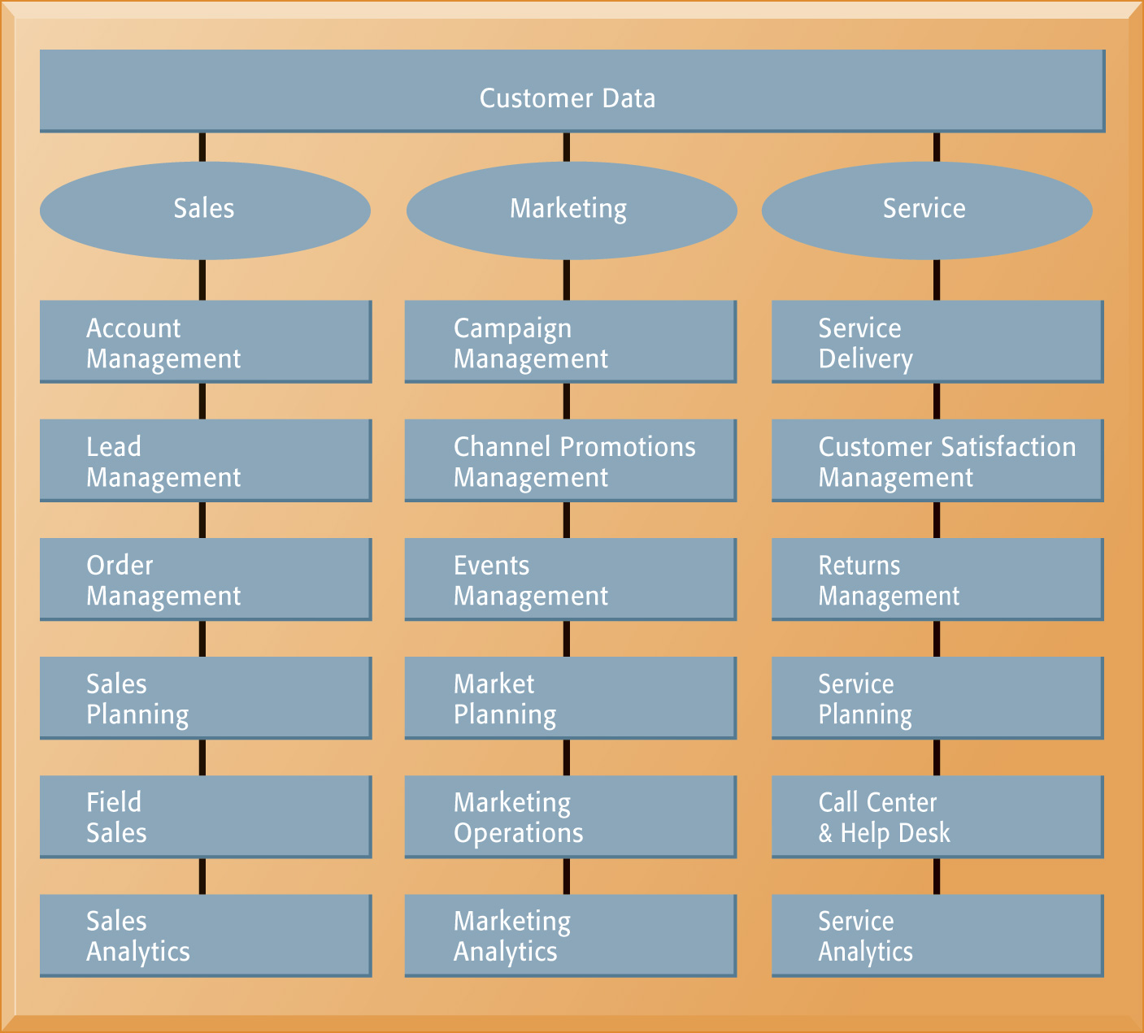

Figure 9.8 CRM Software Capabilities

Operational and Analytical CRM

It’s important to understand the difference between the operational and analytical aspects of CRM systems. Operational CRM includes everything a company should provide those employees who interface directly or indirectly with the customer: the sales force, call centers, and support activities. Managers and decision makers use the analytical CRM to help them improve business performance. The analytical CRM uses data from the operational CRM and provides managers with the opportunity to target smaller, specific customer groups or market segmentation. Rather than trying to blanket a huge group of potential customers, many of whom are not interested, managers use the analytical CRM to focus their efforts on those customers who can offer the most profit at the least cost.

One of the most important benefits of analytical CRM is the ability to determine the customer lifetime value (CLTV). The text mentions that it costs six times more to gain a new customer than to keep an old one. By measuring the CLTV of customers, organizations can calculate customer profitability and determine which customers in which to invest the most effort.

Business Value of Customer Relationship Management Systems

As the old saying goes, “We’re wasting half of our advertising budget; we just don’t know which half.” CRM software will help managers better understand their customers, thereby helping them make better decisions about product lines and marketing campaigns. CRM systems can also help reduce the customer churn rate and identify which customers are most profitable. Hopefully, CRM will help them discover which half of the ad budget is wasted.

Once again, the benefits of using CRM systems are worth the challenges you’ll face.

Benefits:

- Increased customer satisfaction
- Reduced marketing costs
- More effective marketing
- Lower costs for customer acquisition and retention
- Increased sales revenue
- Better response to customer needs

Interactive Session: Organizations: Kenya Airways flies high with Customer Relationship Management (see page 359 of the text) describes how the business improved its customer relationship management and was able to respond much more rapidly to customers. The company is much closer to achieving its goal of knowing and understanding its customers.

Bottom Line: Customer relationship management systems allow a firm to focus all of its energy and attention to developing profitable customers and foregoing unprofitable ones. Useful information produced by CRM systems allow firms to improve business performance while reducing costs associated with gaining and retaining customers. Information can be shared internally and externally.

9.4 What are the challenges that enterprise applications pose, and how are enterprise applications taking advantage of new technologies?

Before implementing enterprise application systems, organizations need a very clear picture of where they are now and where they want to go. Organizations must decide which processes provide the most value and which processes need the most improvement. And, the firm must allocate the organization resources where they are most needed.

Enterprise Application Challenges

The return on investment to companies that implement enterprise systems can be enormous in terms of enhanced information among suppliers, employees, customers, and business partners. The better the information is, the better the decisions. The better the information is, the better the products and services are for the customer. More customers leads to higher profits for the company (hopefully).

Hang on for a rough ride:

- Daunting Implementation: Technological and fundamental changes will pervade every corner of the organization. The organizational structure and culture will change. The most daunting task will be retraining thousands of workers and convincing them the change is good. It will be easier to fail than to succeed.
- High Up-Front Costs and Future Benefits: There is no such thing as an overnight success when implementing an enterprise system. On average, it takes three to five years to fully implement an enterprise system. And, the software is very expensive—very expensive. Keeping the firm on track and focused on the end result is more difficult than most firms anticipate.
- Data Management: It’s more important than ever before. Now that one database serves the entire organization, if data are mismanaged, it will affect every business function and process.
- Inflexibility: Making changes in one area of the business is much more difficult after implementing an enterprise system. The software is just too complex to easily change.
- Realizing Strategic Value: Businesses that rely on unique or cutting-edge processes to gain a competitive advantage may lose that edge with enterprise system software.

Next-Generation Enterprise Applications

As companies get more comfortable with supply chain management and customer relationship management programs they realize the importance of branching out to enterprise solutions, enterprise suites, or e-business suites. Software manufacturers are creating these programs and ensuring firms can integrate data and information more easily with customers, suppliers, and business partners.

We discussed open source software and cloud computing in earlier chapters. Even though they are still in the early stages of development, it shouldn’t surprise you to learn that they are being developed for enterprise applications. Small- and medium-size businesses are the ones most likely to follow this path because it’s much cheaper.

Social CRM

An explosion of social media channels such as Facebook, LinkedIn, and Twitter has occurred over the last few years, giving companies even more ways to reach out to customers. The problem now is to incorporate the new channels with all the data already stored in enterprise systems. Social CRM systems allow that to happen. The new technology provides a way for organizations to uncover sales leads and identify customer support issues.

“Social CRM or social customer relationship management is the integration of social media channels into Customer Relationship Management (CRM) platforms. Increasingly, CRM platforms support social media alongside traditional channels so customers can interact with businesses via their preferred channels. This means better customer service and greater marketing insight gathered from customer social media data. Social CRM makes it possible for a business to communicate with customers using the channel of their choice—whether by phone, text, chat, email or social media (e.g. Facebook or Twitter). Off the back of these interactions, a social CRM system helps businesses gather richer, actionable insight about customer sentiment on their company, their brand, and specific products or services.
The best CRM systems are able to take this dynamic customer profile and put it to good use by disseminating that information across different teams, including customer service, marketing and sales.
Social CRM has the potential to deliver returns across and between several core business functions.
By tracking and managing customer contacts across channels and business functions, customer service teams can deliver dramatically better service and markedly improve resolution times.
Some 79% of Salesforce customers reported improved customer service, and 63% increased customer retention – demonstrating that social CRM delivers real commercial benefits.
Track each prospect’s progress and location within the sales funnel using a social CRM. Sales teams can create a personalized experience for specialized users, rather than using the traditional CRM blanket approach.
Beyond individualization, sales teams can expect to see an improvement in retained and referred business as customers become recommenders and advocates; and that leads to increased revenue. In a survey of Salesforce customers, 55% reported increased customer loyalty and 54% increased sales revenues.
Marketers can use social CRM to increase reach while improving customer tracking and measurement. This can feed back into other marketing tactics and help drive lead generation and sales.
In one Social Media Examiner survey, 89% of respondents said social media increased their brand’s exposure, while nearly half reported that spending just 6 hours a week on social media activity reduced overall marketing costs.”
(The Business case for social CRM, https://www.salesforce.com/eu/learning-centre/crm/social-crm/#case, copied March 22, 2019)

Business Intelligence in Enterprise Applications

Being able to generate ad hoc analyses, use interactive dashboards, ask “what-if” questions, and take advantage of data visualization tools are becoming more important than ever to system users and executives. They don’t want to have to leave one system and move to another in order to use these business intelligence tools. Enterprise application vendors are incorporating these tools into their systems to provide a “one-stop shopping” experience for users.

Bottom Line: All of the challenges of implementing a new enterprise system are directly related to people. Many organizations fail to understand this fact and pay more attention to the hardware and software elements of the new system. The real emphasis should be placed on the persware element of the new system instead.

9.5 How will MIS help my career?

The chapter’s elements and information can help in securing a good job as a manufacturing management trainee. This position will provide training on critical skills and industry experience in plant, technical, and corporate environments. These types of jobs are becoming more popular as information technology becomes more important in the workplace.

Discussion Questions:

- How does enterprise software enable a business to use industry-proven best practices?

- Explain the bull-whip effect on a supply chain and how it can be avoided.

- Describe the difference between push-based supply models and pull-based supply models.

- Describe the difference between operational customer relationship management systems and analytical customer relationship management systems.

- Discuss the role of open source software and cloud computing in enterprise applications.

Answers to Discussion Questions:

- Enterprise software uses predefined processes that require a business to adapt itself to the software. The processes have been created by the software manufacturer based on industry-proven best practices. The processes are difficult to modify because the software is so complex. Any changes to one area may disable or distort another process in a different area.

- Information about the demand for a product may be distorted between suppliers and businesses. Each entity in the supply chain alters its decisions about product demand and could cause an over- or under-supply of products. By providing immediate and accurate information up and down the supply chain, all partners can adjust their sourcing, manufacturing, and distribution plans.

- Push-based supply models depend on the forecasts or best guesses of demand for products and are pushed to the customer by the manufacturer. Pull-based supply models are customer-driven and depend on actual customer orders or purchases before the manufacturer commits to building the product or providing the service. See Figure 9.4 in the text.

- Operational CRM are customer-facing applications, such as sales force automation, call center and customer service support, and marketing automation. Analytical CRM systems analyze customer data to provide information for improving business performance. Managers and executives use analytical CRM systems in conjunction with online analytical processing, data mining, and other data analysis techniques to create a total picture of the customer.

- Next generation enterprise applications will incorporate aspects of open source software and cloud computing because it reduces the overall licensing fees. As software-as-a-service continues to expand, small- and medium-size businesses will find these types of solutions more feasible because the technology demands are less than internal-based enterprise applications.

